Content Research and Sourcing
Organisation Website
The official Lunchbox Fund site – thelunchboxfund.org.za
Home Page:
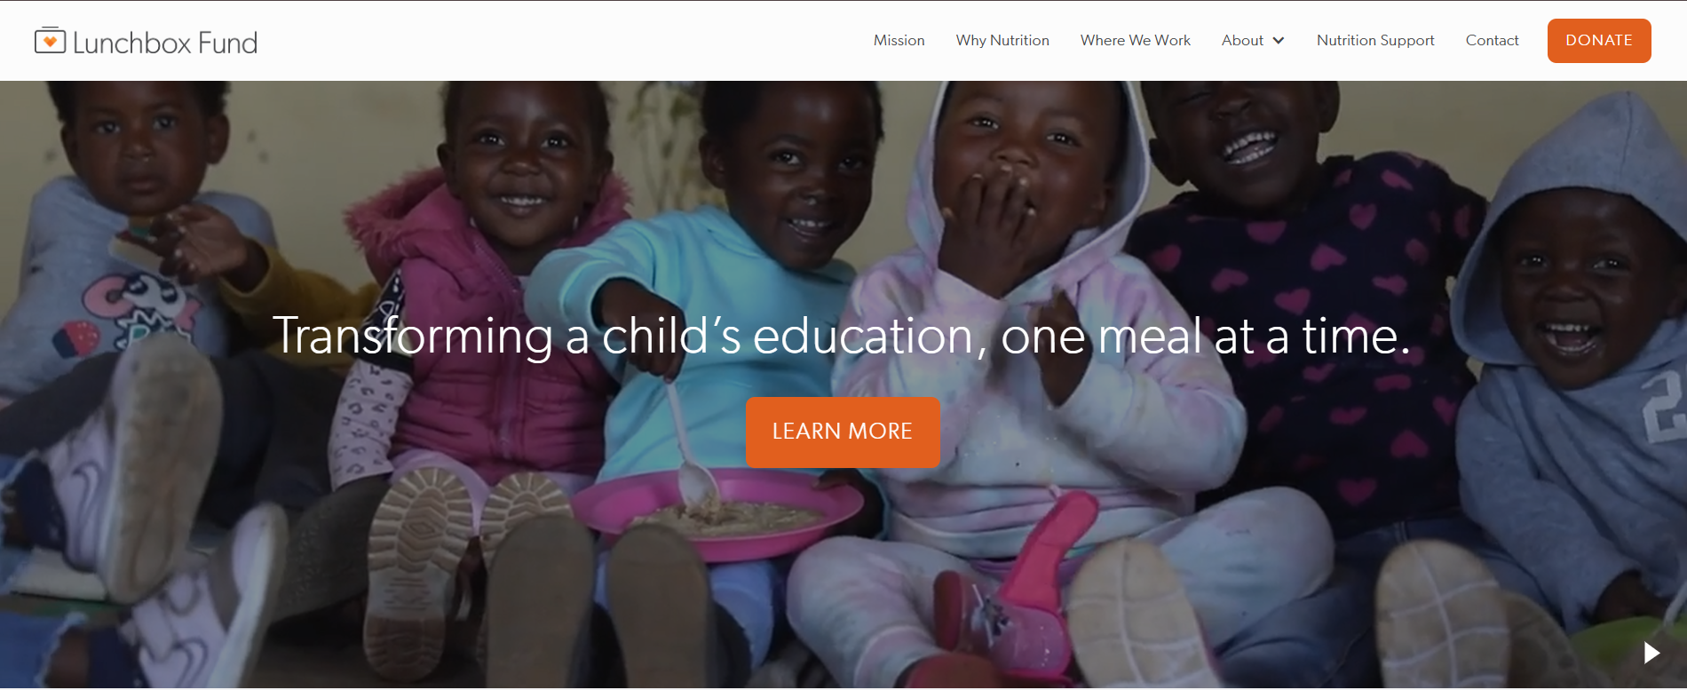
The lunchbox fund is a nonprofit organization that provides nutritious meals to vulnerable schoolchildren, helping them attend school, concentrate on their education and improve their future opportunities.
Headline: Transforming a child’s education, one meal at a time.
Vision & mission:
The vision of the Lunchbox Fund is to foster education through nutrition by providing healthy meals daily to orphaned, vulnerable, and food-insecure schoolchildren in townships and rural areas. Its mission is to uphold children’s right to education by ensuring that hunger and food insecurity do not prevent them from learning.
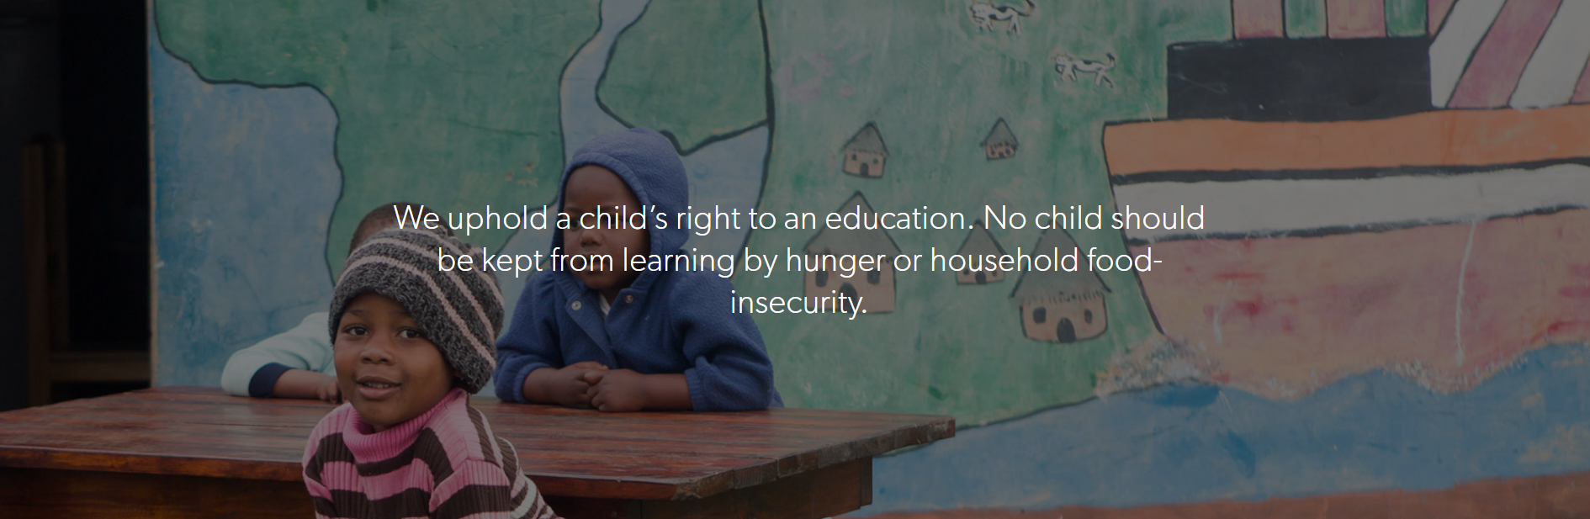

Statistics on the impact the organization has had:
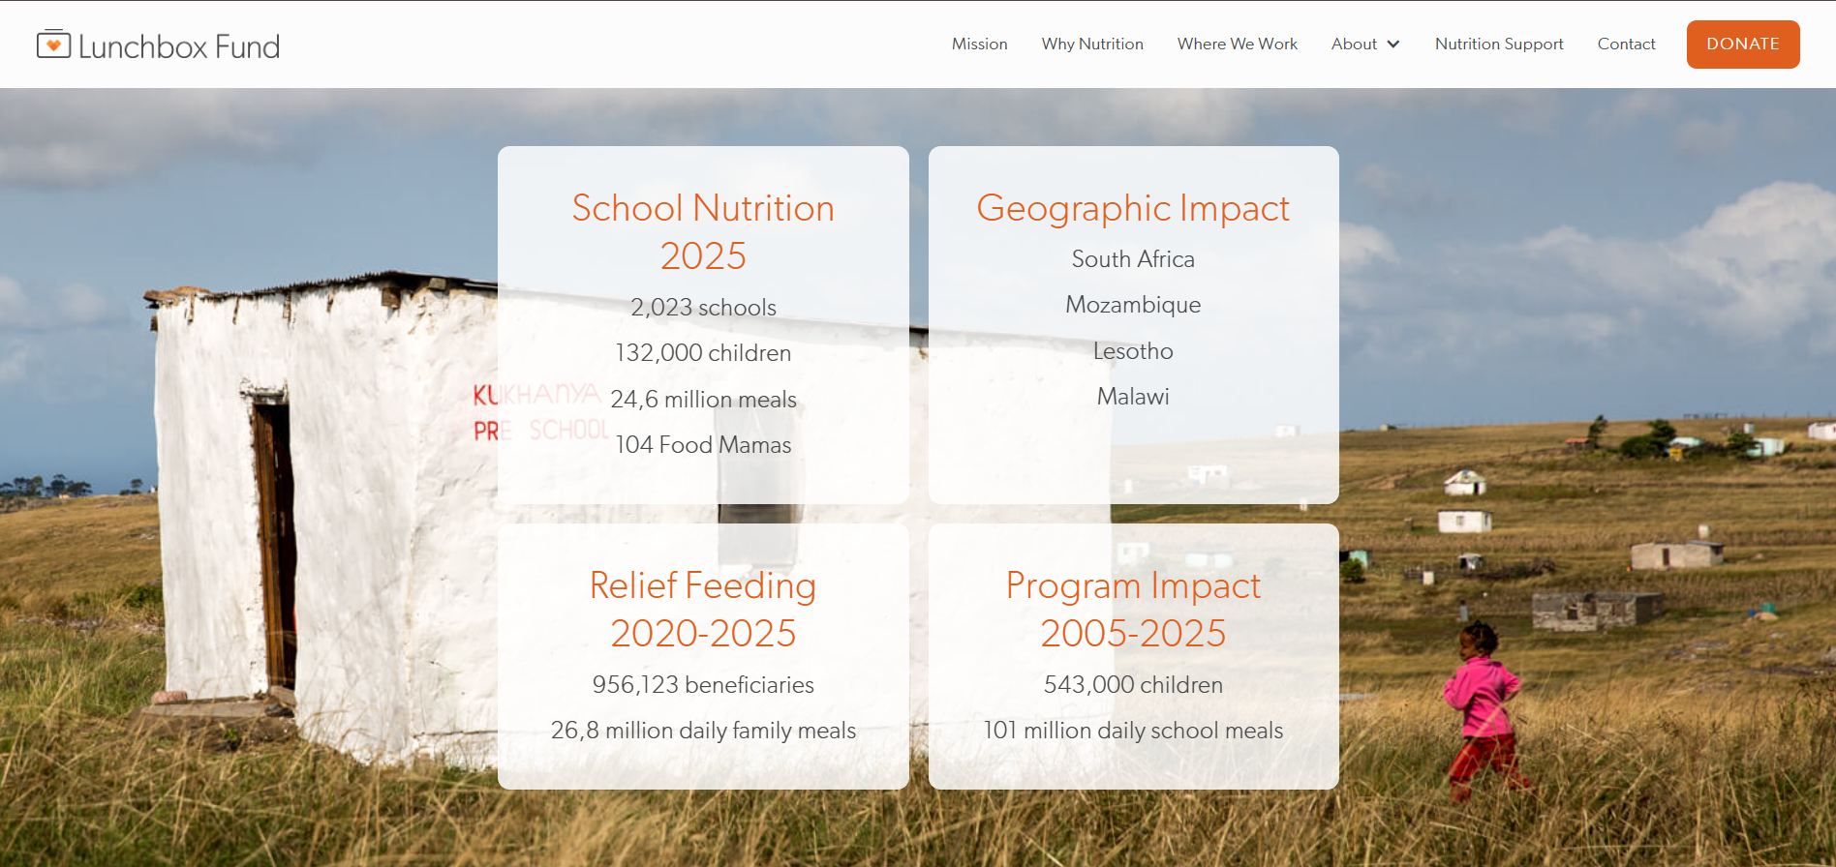

Places of Work:
- South Africa
- 115,000 children
- 1,910 Primary/Secondary Schools, Early Childhood Development Programs and After-School Initiatives
- 104 Food Mamas (Cooks)

- Mozambique
- 8,000 children
- 42 Primary/Secondary Schools and Early Childhood Development Programs
- 41 Food Mamas (Cooks)

- Lesotho
- 250 children
- 5 Early Childhood Development Programs

Contact information
Email: info@thelunchboxfund.org
Phone: +27(0)793660884
Adress:
The Lunchbox Fund
P.O. BOX 10
New York, NY 10276

Social Media
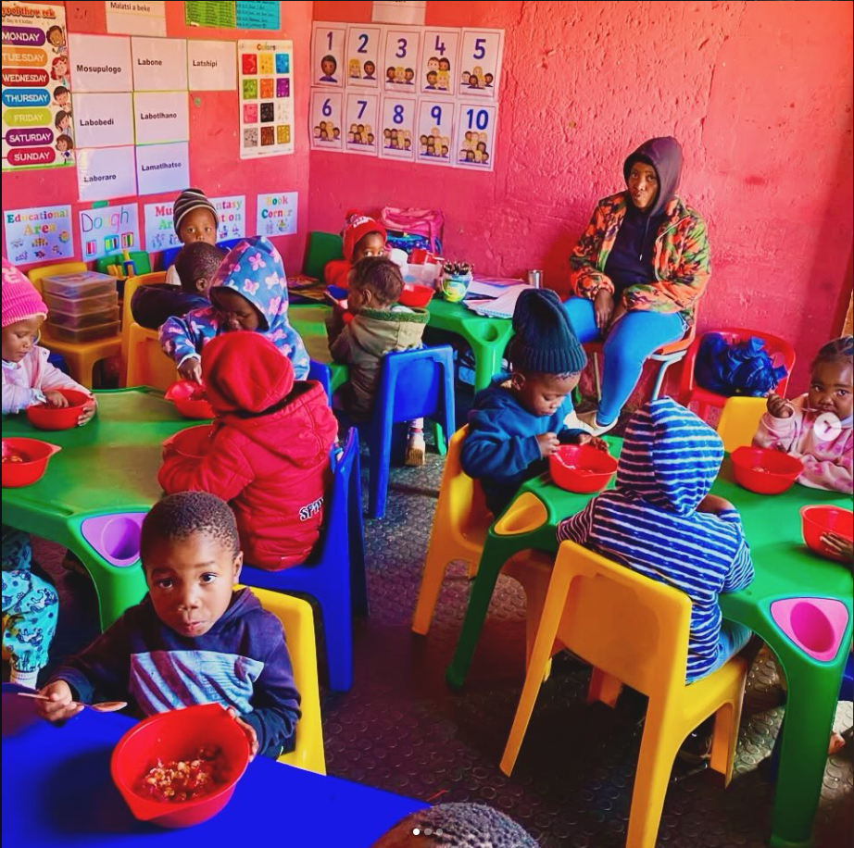

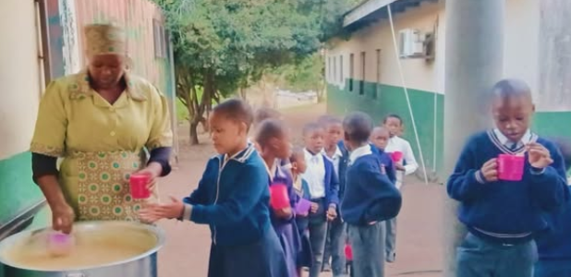

Public domain and Creative Commons resources
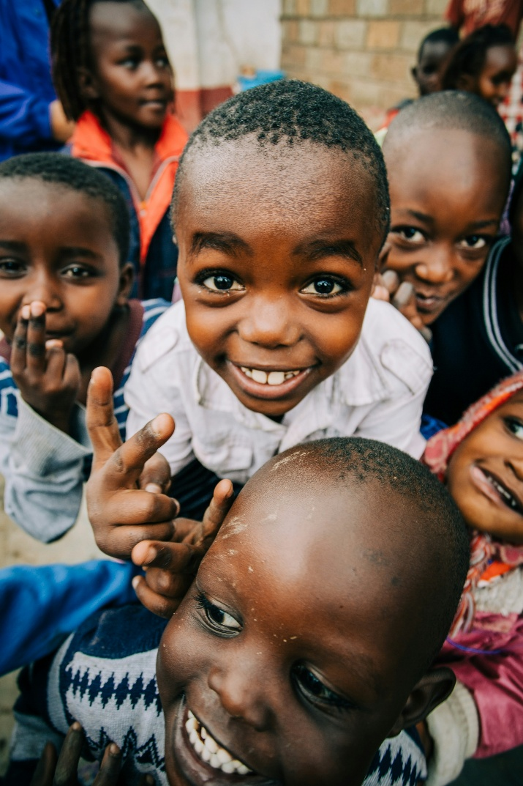
Photo by bennett tobias on Unsplash
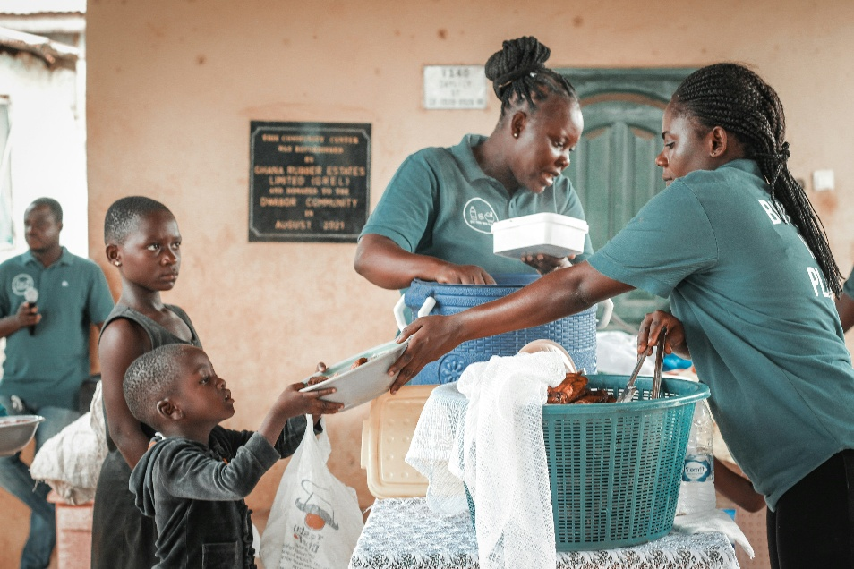

Photo by Khalil Radi on Unsplash

Photo by Markus Winkler on Unsplash

